**Department of Engineering Technology**



**Foundation University Islamabad** **School of Science and Technology**

**DSA Lab**

**Name: Muhammad Usman**

**Roll no: 079**

**Lab#: 03**

**Topic: _______ OBJECTIVES:**

i. Objective - 1 ii. Objective - 2

|  |  |  |  |  |  |
| --- | --- | --- | --- | --- | --- |
| **Performance** | |  | **Lab Report** | |  |
| **Description** | **Total**  **Marks** | **Marks Obtained** | **Description** | **Total**  **Marks** | **Marks** **Obtained** |
| Implementation of Code | 5 |  | Lab Exercises | 5 |  |
| **Total Marks obtained** | |  |  | |  |

**Q1:**

#include <iostream>

using namespace std;

const int MAX = 100;

int queue[MAX];

int front = -1, rear = -1;

void Enqueue() {

int val;

if (rear == MAX - 1) {

cout << "Queue Overflow! Cannot insert more elements.\n";

} else {

cout << "Enter value to enqueue: ";

cin >> val;

if (front == -1) front = 0; // First element

rear++;

queue[rear] = val;

cout << val << " inserted into queue.\n";

}

}

void Dequeue() {

if (front == -1 || front > rear) {

cout << "Queue Underflow! No element to delete.\n";

} else {

cout << "Deleted element: " << queue[front] << endl;

front++;

}

}

void Display() {

if (front == -1 || front > rear) {

cout << "Queue is empty.\n";

} else {

cout << "Queue elements: ";

for (int i = front; i <= rear; i++) {

cout << queue[i] << " ";

}

cout << endl;

}

}

int main() {

int choice;

cout << "=== Queue Operations Menu ===\n";

cout << "1. Enqueue (Insert)\n";

cout << "2. Dequeue (Delete)\n";

cout << "3. Display Queue\n";

cout << "4. Exit\n";

do {

cout << "\nEnter your choice: ";

cin >> choice;

switch (choice) {

case 1:

Enqueue();

break;

case 2:

Dequeue();

break;

case 3:

Display();

break;

case 4:

cout << "Exiting program.\n";

break;

default:

cout << "Invalid choice! Please try again.\n";

}

} while (choice != 4);

return 0;

}

**Output:**

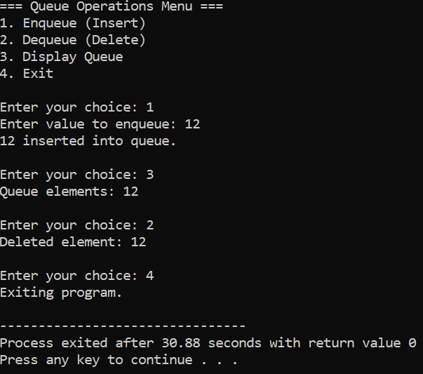

**Q2:**

#include<iostream>

#include<cstring>

#include<queue>

using namespace std;

int main(){

char input[200];

cout<<"Enter a string: ";

cin.getline(input,200);

char words[50][50];

int wordCount=0;

char *token=strtok(input," ");

while(token!=NULL){

strcpy(words[wordCount],token);

wordCount++;

token=strtok(NULL," ");

}

for(int i=0;i<wordCount;i++){

cout<<"Q"<<i+1<<" = ";

queue<char> q;

int len=strlen(words[i]);

for(int j=0;j<len;j++){

q.push(words[i][j]);

}

while(!q.empty()){

cout<<q.front();

q.pop();

if(!q.empty()) cout<<" -> ";

}

cout<<endl;

}

return 0;

}

**Output:**

